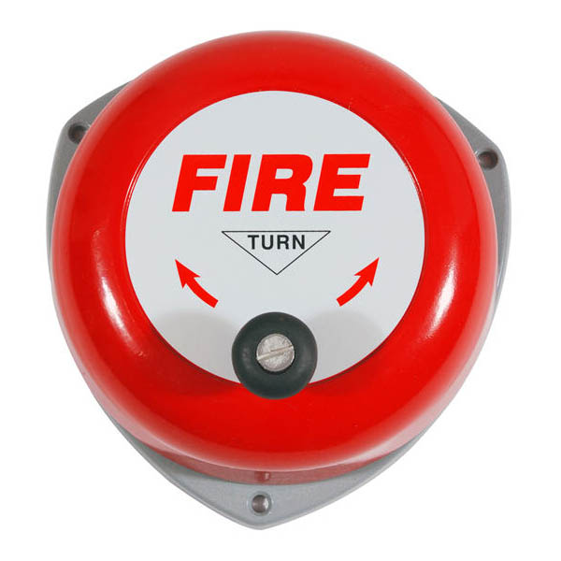

*Avish Jain 13116014 Mohit Gupta 13116042 Shubham Jain 13116062*  
  
Faculty Advisor: Bishnu Prasad Das

FIRE ALERT SYSTEM

# Objective

To make an IOT based fire alert system using Raspberry pi, Temperature Sensor, Smoke Sensor and LED Screen.

# overview

# Working

### RAspberry pi

* The Raspberry Pi is a low cost, computer that plugs into a computer monitor or TV, and uses a standard keyboard and mouse.
* A 900MHz quad-core ARM Cortex-A7 CPU & 1GB RAM
* It’s capable of doing everything a desktop computer can do (from browsing the internet to playing high-definition video) in addition with the ability to interact with outside world using its 26 GPIO pins.
* These pins are a physical interface between the Pi and the outside world.
* GPIO pins can be thought of as switches that can be turned on or off (input) or that the Pi can turn on or off (as an output).
* It has many hardware ports like HDMI, display, Camera, Ethernet, micro-SD card slot and has 4 USB ports.

### ALPHANUMERIC LCD DISPLAY (16 X 2)

The 16 x 2 intelligent alphanumeric dot matrix display is capable of displaying 224 different characters and symbols with a built in controller. It has 16 pins, of which 8 are data pins.

### Temperature Sensor (DS18B20)

The temperature sensor DS18B20 has 3 pins- Vcc, Ground and a DQ pin for sending information to/from the DS18B20 over a 1-Wire interface 1 port communication with raspberry pi. The DS18B20 Digital Thermometer provides 9 to 12-bit (configurable) temperature readings which indicate the temperature of the device. It takes a maximum time of 750ms to convert the 12-bit temperature to digital word. It measures temperatures from -55°C to +125°C. and Fahrenheit equivalent is -67°F to +257°F.The resolution of the DS18B20 is configurable (9, 10, 11, or 12 bits), with 12-bit readings the factory default state. This equates to a temperature resolution of 0.5°C, 0.25°C, 0.125°C, or 0.0625°C. The sequential 12 bits provide temperature reading to the raspberry pi which is then sent to the LCD display after every second. When the smoke sensor detects smoke and temperature in the room goes above the set threshold, an alert is created.

### Smoke sensor (MQ2)

MQ2 is a Domestic and Industrial gas leakage detector. Features like good sensitivity to combustible gas in wide range, long life and low cost make it the best option. The sensitive material of MQ-2 gas sensor is SnO2, which has lower conductivity in clean air. But when the combustible gas or smoke exist, the conductivity of the SnO2 rises with rise in gas concentration. Change in the conductivity corresponds to change in output voltage level. The MQ-2 smoke sensor reports smoke by the voltage level that it outputs. More the concentration of smoke present, greater the voltage it outputs. There is also inbuilt analog to digital converter in the smoke sensor. The MQ-2 also has a built-in potentiometer to adjust the sensitivity to smoke. The range of concentration of smoke it can detect is 200ppm-10000ppm.

# Bibliography

* Raspberrypi.org
* Dallas semi-conductor DS18B20 datasheet
* Adafruit online tutorial for raspberry pi and DSB18B20 interfacing
* MQ2 sensor datasheet